About this Document
Applies to Chronolator Versions | All versions
Document version | 3.5.01
Purpose | New customers have often already started a review before they buy a Chronolator licence. This document outlines how Chronolator can be used to improve the process of assembling a multi-agency chronology from a collection of non-Chronolator documents. It uses an example based on a table received from an actual customer.

Overview
The process involves three main steps:
- Create a blank Internal Chronology which matches the table in the non-Chronolator documents as closely as possible;
- Use the Internal Chronology to create Chronolator versions of each non-Chronolator document;
- Use Chronolator to merge the Chronolator versions together.
These steps are described in more detail below.

Step 1: Create a blank Chronolator Document
The blank Chronolator Document you create should match the function (but not necessarily the text) of the column headings in the incoming documents as closely as possible. Bear in mind that Chronolator requires its ‘special columns’ to be in a certain order.

Special columns
Every Chronolator Document contains Start Date and Source of Information columns. It can also contain Start Time, End Date and End Time columns. These special columns always appear at the left of the table, in the order Start Date, Start Time, End Date, End Time, and Source of Information. You cannot override this order, so if the columns in your incoming documents are in a different order you will need to move them about when 'Chronolatorising' them.
The text in the column headings does not have to match the name by which Chronolator refers to them. A typical table might just have Start Date and Source of Information columns with headings like this:
Date | Source | What happened | Comments
If a Start Time column was included, it would appear between the Start Date and Source of Information columns, like this:
Date | Time | Source | What happened | Comments

Review the headings in the incoming documents
We shall use this table as an example incoming non-Chronolator document:
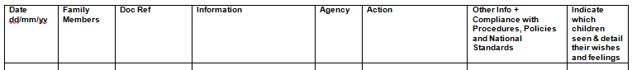
Check which headings in the incoming documents might match the special columns used by Chronolator. For example, in the table above, the first column obviously matches a Chronolator Start Date, and the third one is a likely candidate for Source of Information.
Review the conciseness of the other headings. The last two headings in the example are fairly typical of those used in many non-Chronolator reviews in that they are quite wordy. There is nothing wrong with long headings per se, and you could set up your blank Chronolator Document to match them. However, it is recommended that you choose shorter ones; if nothing else, this saves paper and screen space when the heading row is repeated on each page.
The Agency column in the above example is likely to be redundant, as Chronolator adds the information about where a document came from to the Source of Information column when it is imported into a multi-agency chronology.
The example does not contain a column where people can include the time of an event. This often means that people will put times into the Date column (the most logical place). Chronolator will flag these as errors. If your incoming documents are likely to contain times, consider adding a Start Time column.
The Family Members column might be a good candidate for Chronolator's Abbreviations Glossary - refer to Setting Up Chronolator Documents section 4.4.2.7 and Using Chronolator Documents section 6.3 for more details.

Decide what headings to use in the Chronolator Document
Bearing in mind the above considerations, the recommended headings to use in the blank Chronolator Document would be something like this:

Create a blank Chronolator Document
Open the Chronolator Online Workbench and press the New Internal Chronology button. This will open the Case Details Wizard. Follow the instructions in it to create a blank Chronolator Document with the column headings you have decided to use. Resist any temptation to make any of the columns ‘Must Fill’ - you will only be giving yourself a headache.
As you will be copying the non-Chronolator documents into the Chronolator Document, you should now delete the contents of the latter: the easiest way to do this is to press Ctrl-A, then Delete.

Step 2: create Chronolator versions of each non-Chronolator document
The aim of this step is to leave your incoming documents unchanged so they remain as part of your audit trail, and to make Chronolator versions of them that you can check for errors before merging them into a Composite Chronology.
Follow these steps for each incoming document:
- Open the blank Chronolator Document;
- Copy the incoming document into the Chronolator Document. You could do this with Copy and Paste, or use a Word command (in Word 2010, for example, use Insert > Text > Object > Text from file
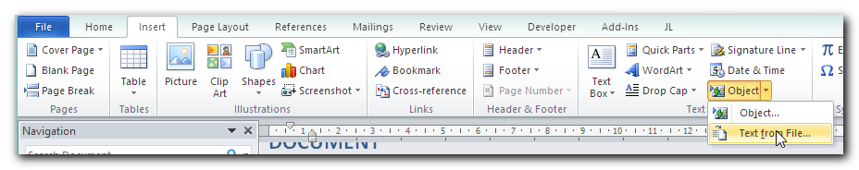;
- If necessary, move and delete columns and text so they are what Chronolator expects (in the example above, the Doc Ref column would be moved, the Agency column deleted, and any times in the Date column moved to the Time column);
- Replace the text in the original heading row with the text Chronolator requires. A simple way to do this is to press Admin > New Table on the Chronolator toolbar; this creates a new table at the end of the document whose column headings can be copied and pasted;
- Press Admin > Show Document Details. Under the Miscellaneous heading at the bottom of the report, check the Table and Row counts. There should be one table, and the row count should be what you expected for the incoming document. If not, check the incoming document to see if it contained more than one table; if so, either update the headings in each table, or put everything into one table.
- If all is OK, you now have a Chronolator version of the incoming document. Save it using a suitable name - for example Agency A Chronolator.docm.
- Press Check Tables and deal with any errors.

Step 3: Use Chronolator to merge the Chronolator versions together
Refer to the instructions in the Using Chronolator Documents manual for this step.

Date and Source of Information columns are always ‘Must Fill’; you cannot change this.
The latter is preferable; when there are multiple tables, Chronolator checks each one separately, and date sequence errors across tables will be missed. However, if it is too difficult to put everything in one table (because the tables have different column widths for example), you can be sure that Chronolator will include all matching tables in your Composite Chronology.

